Continuous Integration and Continuous Deployment Lab

Experiment – 2

**Name – Harivansh Mathur**

**Roll No – R171218043**

**Jenkins Integration with GitHub**

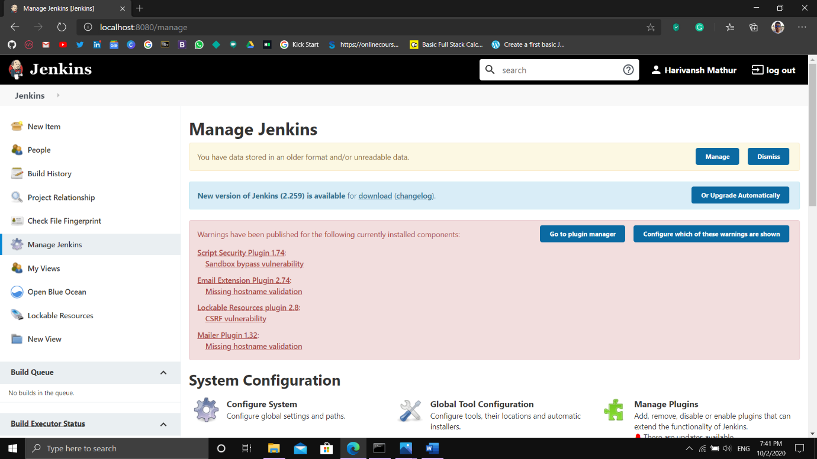

On Jenkins Dashboard, go to Manage Jenkins and select Global Tool Configuration

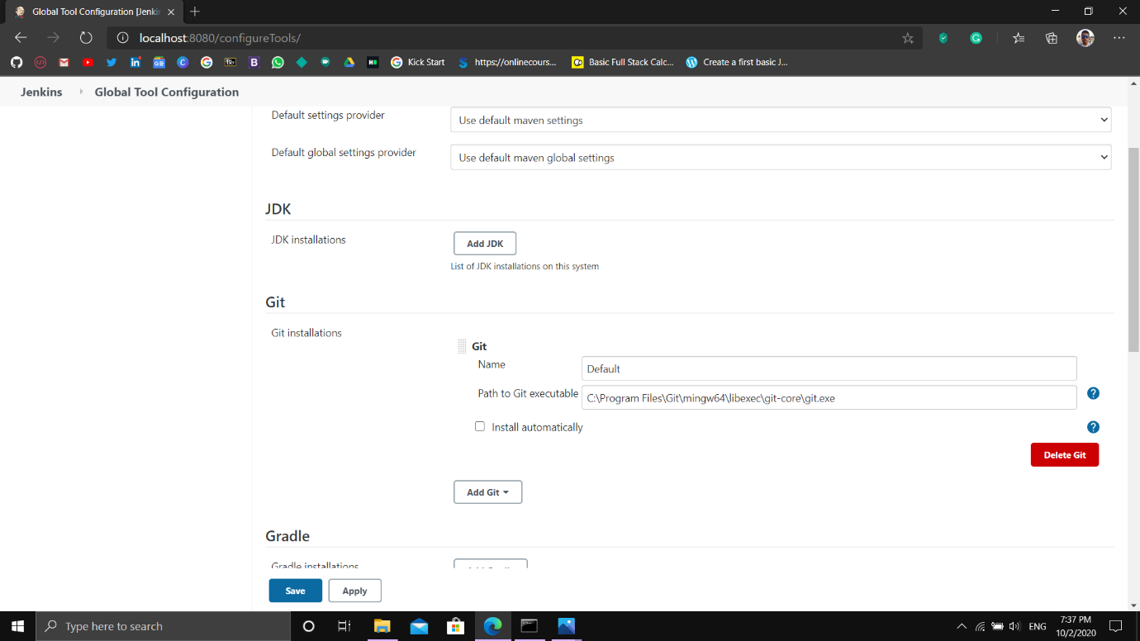

Add Git directory in this section and apply and save the changes